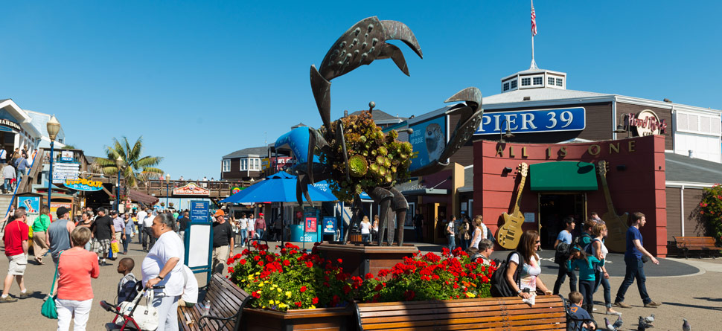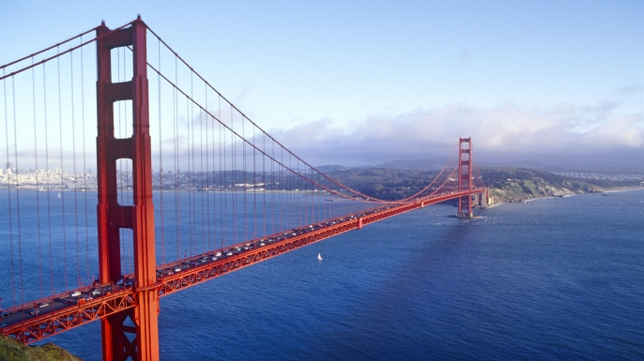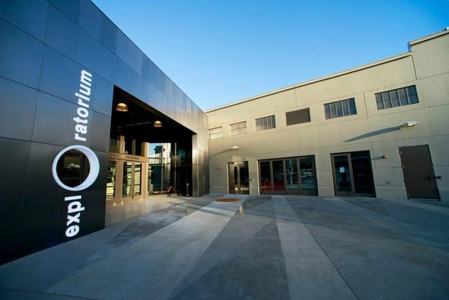
Footsteps ESL Camp Bay Area Schedule 2019
Friday 2 | Saturday 3 | Sunday4 | 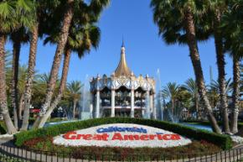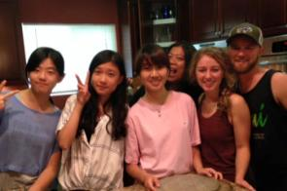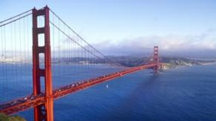 | Friday 7  Saturday 8  Sunday 9  Breakfast  Breakfast and Check Out  Exploratorium  Golden Gate Bridge  Lunch  Lunch  Arrive at SFO  Pier 39 and Fisherman’s Wharf  Check into hotel  Dinner  Host Family Meet & Greet Dinner  Return to hotel  Lights out  Lights out  First night with Host Family  Drive to Redding  Footsteps ESL Camp Redding Schedule 2017
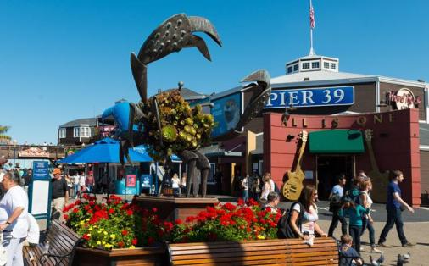  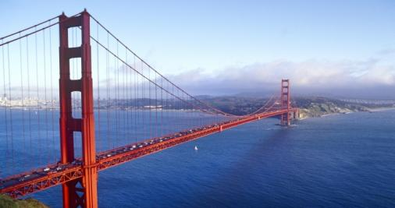  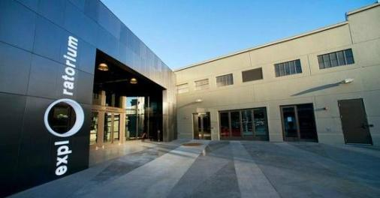 | Breakfast | Breakfast with Homestay
 | Great America Amusement Park | Homestay Family Day  Spend a Day with an American Family
Arrive at SFO
Check into hotel | Dinner
 | Homestay Family Pickup
Lights out | First Night with Homestay | Dinner and Activities with Host Family

Monday 5 | Tuesday 6 | Wednesday 7 | Thursday 8 | Friday 9
Breakfast with Host Family | Breakfast with Host Family | Breakfast with Host Family | Breakfast with Host Family | Breakfast with Host Family
Testing  ESL Class (Health) | Opening & Music | Opening & Music | Opening & Music | Opening & Music
 | ESL Class (Hospital) | ESL Class (Olympics) | ESL Class (Weather) | ESL Class (Solar System)
Lunch | Lunch | Lunch | Lunch | Lunch
Storytime & Music | Storytime & Music | Storytime & Music | Storytime & Music | Google Tour
Cooking  (Recipe Books) | Cooking  (Deviled Eggs) | Cooking  (Sloppy Joes) | Cooking  (Taco Soup)
Crafts  (Dragonfly) | Crafts  (Mosaic) | Crafts  (Origami) | Crafts  (Masks)
Break | Break | Break | Break
Simulations  (Appointments) | Simulations  (Compliments) | Simulations  (Exercising) | Simulations  (Going to the Bank)
Closing | Closing | Closing | Closing
Dinner with Host Family | Dinner with Host Family | Dinner with Host Family | Dinner with Host Family | Dinner with Host Family
Footsteps ESL Camp Bay Area Schedule 2019

Saturday 10 | Sunday 11 | Monday 12 | Tuesday 13 | Wednesday 14 | Thursday 15 | Friday 16
Breakfast with Host Family | Breakfast with Host Family | Breakfast with Host Family | Breakfast with Host Family | Breakfast with Host Family | Breakfast with Host Family | Breakfast with Host Family
San Francisco Tour Day  Ghiradelli Square  Pier 39 Aquarium  Cruise on the Bay  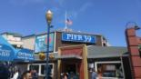 | American Church Service | Opening & Music | Opening & Music | Opening & Music | Opening & Music | Opening & Music
 | Lunch | ESL Class (Camping) | ESL Class (Geography) | ESL Class (African Savannah) | ESL Class (Great Barrier Reef) | ESL Class (The Outback)
 | Wiener Dog Races | Lunch | Lunch | Lunch | Lunch | Lunch
 |  | Storytime & Music | Storytime & Music | Storytime & Music | Storytime & Music | Silicon Valley Tour
 | Stanford University Tour | Cooking  (Potato Salad) | Cooking  (Owl Crackers) | Cooking  (Racing Cars) | Cooking  (Popcorn Planets)
 | Dinner | Crafts  (Caterpillar) | Crafts  (Jeweled Frogs) | Crafts  (Lanyards) | Crafts  (Sun Visors) | Graduation Ceremony Talent Show
 |  | Break | Break | Break | Break
Dinner with Host Family | Dinner and Activities with Host Family | Simulations  (Grocery Store) | Simulations  (Let’s Eat) | Simulations  (Take a Trip) | Simulations  (Gifts)
 |  | Closing | Closing | Closing | Closing
 |  | Dinner with Host Family | Dinner Host Family | Dinner Host Family | Dinner with Host Family | Dinner with Host Family
Footsteps ESL Camp Bay Area Schedule 2019

Saturday 17 | Sunday 18 | Monday 19 | Tuesday 20 | Wednesday 21 | Thursday 22
Breakfast with Host Family | Breakfast at Camp | Breakfast at Camp | Breakfast at Camp | Breakfast at Camp | Breakfast at Camp
Drive to Santa Cruz  Tour of Mt. Hermon  Downtown Santa Cruz Tour | Outdoor Adventure Camp:  American Church Service  Marine Discovery Center  Santa Cruz Surfing Museum | Outdoor Adventure Camp:  UC Santa Cruz Tour  Wilder Ranch State Park | Outdoor Adventure Camp:  Natural Bridges  Santa Cruz Beach Boardwalk | Outdoor Adventure Camp:  Roaring Camp Railroads Park  Henry Cowell Redwoods State Park  Beach Bonfire at Seabright Beach | Drive to SFO
 |  |  |  |  | Depart SFO
 |  |  |  |  | 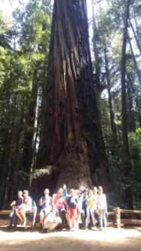
Dinner at Camp | Dinner at Camp | Dinner at Camp | Dinner at Camp | Dinner at Camp
Footsteps ESL Camp Bay Area Schedule 2019

