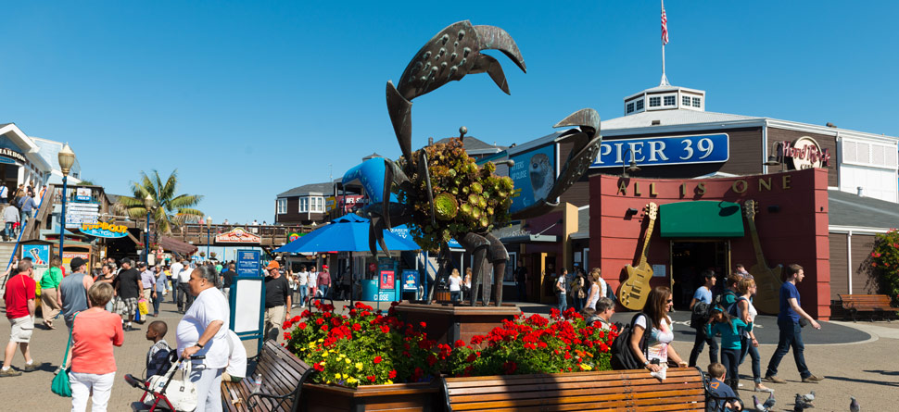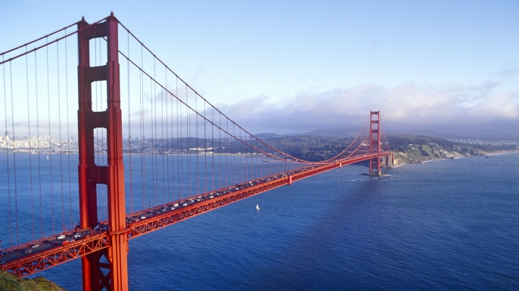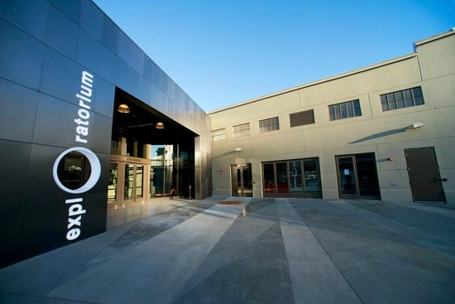
Footsteps ESL Camp Redding Schedule 2019
Friday 12 | Saturday 13 | Sunday 14 | 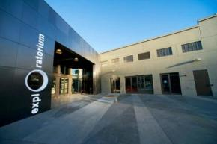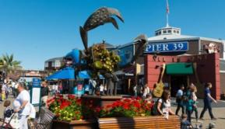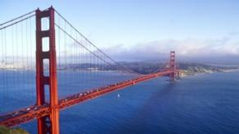 | Friday 7  Saturday 8  Sunday 9  Breakfast  Breakfast and Check Out  Exploratorium  Golden Gate Bridge  Lunch  Lunch  Arrive at SFO  Pier 39 and Fisherman’s Wharf  Check into hotel  Dinner  Host Family Meet & Greet Dinner  Return to hotel  Lights out  Lights out  First night with Host Family  Drive to Redding  Footsteps ESL Camp Redding Schedule 2017
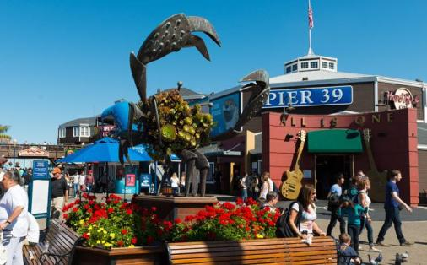  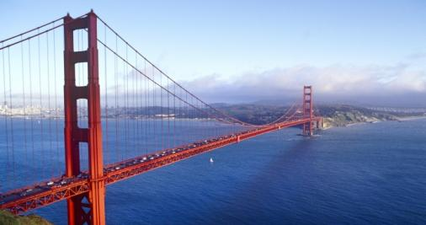  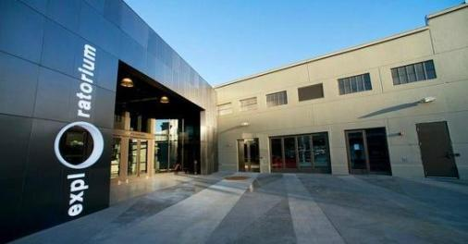 | Breakfast | Breakfast and Check Out
 | Exploratorium | Golden Gate Bridge
 | Lunch | Lunch
Arrive at SFO | Pier 39 and Fisherman’s Wharf | Drive to Redding
Check into hotel | Dinner | Host Family Meet & Greet Dinner
 | Return to hotel
Lights out | Lights out | First night with Host Family

Monday 15 | Tuesday 16 | Wednesday 17 | Thursday 18 | Friday 19
Breakfast with Host Family | Breakfast with Host Family | Breakfast with Host Family | Breakfast with Host Family | Breakfast with Host Family
Testing  ESL Class (A Day at the Beach) | Opening & Music | Turtle Bay Museum  Field Trip | Opening & Music | Opening & Music
 | ESL Class (Friendship) |  | ESL Class (Landmarks) | ESL Class (A Day at the Zoo)
Lunch | Lunch | Lunch | Lunch | Lunch
Storytime & Music | Storytime & Music | 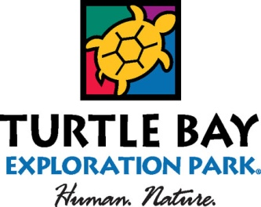 | Storytime & Music | Storytime & Music
Cooking  (Brownies) | Cooking  (Cake) |  | Cooking  (Pie) | Cooking  (Tacos)
Crafts  (Tie Dye) | Crafts  (Water Color) |  | Crafts  (Picture Frames) | Crafts  (Painting Cars)
Break | Break | Break | Break | Break
Woodshop  (Derby Car Design) | Woodshop  (Derby Car Woodshop) | Woodshop  (Derby Car Woodshop) | Woodshop  (Derby Car Woodshop) | Woodshop  (Derby Car Assembly)
Closing | Closing | Closing | Closing | Closing
Dinner and Activities with Host Family | Dinner and Activities with Host Family | Dinner and Activities with Host Family | Dinner and Lake Day | Dinner and Activities with Host Family
Footsteps ESL Camp Redding Schedule 2019

Saturday 20 | Sunday 21 | Monday 22 | Tuesday 23 | Wednesday 24 | Thursday 25 | Friday 26
Breakfast with Host Family | Breakfast with Host Family | Breakfast | Breakfast | Breakfast | Breakfast | Breakfast
Host Family Day  Spend a day with an American family | American Church Service | Camp Activities/ESL  (Occupations) | Camp Activities/ESL  (School ) | Camp Activities/ESL  (Survival Language) | Camp Activities/ESL  (Transportation) | Camp Activities/ESL  (Food)
 | Lunch | Lunch | Lunch | Lunch | Lunch | Lunch
 | Afternoon with Host Family | Camp Time | Camp Time | Camp Time | Camp Time | Camp Cleanup
 |  | Break | Break | Break | Break | Depart from Camp
 | Depart for Camp | Outdoor Learning  (Water Hole) | Outdoor Learning  (American Camping) | Outdoor Learning  (Nature) | Outdoor Learning  (Woodworking)
 | Dinner | Dinner | Dinner | Dinner | Dinner | Afternoon with Host Family
 | Camp Activities  (Camp Intro) | Camp Activities  (Night Games) | Camp Activities  (Under the Stars) | Camp Activities  (Talent Show) | Camp Activities  (Movie Night)
Dinner and Activities with Host Family | Showers/Cabin Time | Showers/Cabin Time | Showers/Cabin Time | Showers/Cabin Time | Showers/Cabin Time
 | Lights Out | Lights Out | Lights Out | Lights Out | Lights Out | Dinner with Host Family
Footsteps ESL Camp Redding Schedule 2019

Saturday 27 | Sunday 28 | Monday 29 | Tuesday 30 | Wednesday 31 | 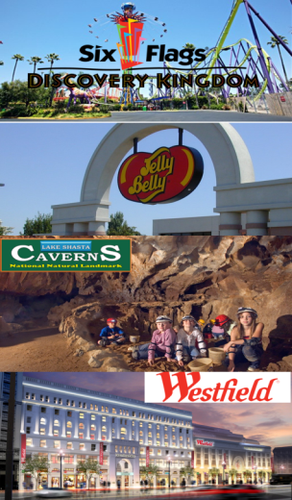
Breakfast with Host Family | Breakfast with Host Family | Breakfast with Host Family | Breakfast with Host Family | Breakfast
Host Family Day  Spend a day with an American family | American Church Service | Cave Exploration at Lake Shasta Caverns  Picnic Lunch | Depart for Six Flags Amusement Park | Check Out of Hotel
 | Lunch |  | Six Flags Amusement Park | Tour Jelly Belly Factory
Host Family Day

Spend a day with an American Family
 |  |  |  | Lunch
 |  |  |  | Shopping and Dinner at Westfield San Francisco Center
 |  |  | Dinner
 |  |  | Check Into Hotel | Drive to SFO
Dinner and Activities with Host Family | Dinner and Activities with Host Family | Dinner and Activities with Host Family | Lights Out | Depart SFO
Footsteps ESL Camp Redding Schedule 2019

